**Output of Assignment - Implement of a locking schema to protect a share file in a Distributed System.**

1. **Operation One Output**

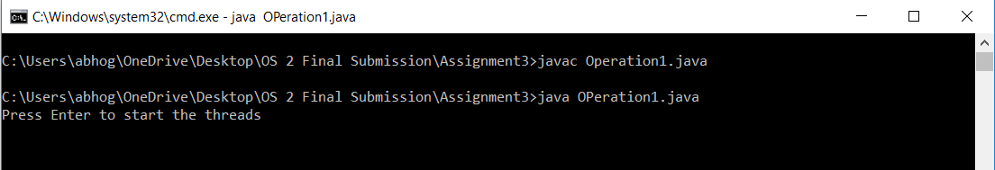

**2.**

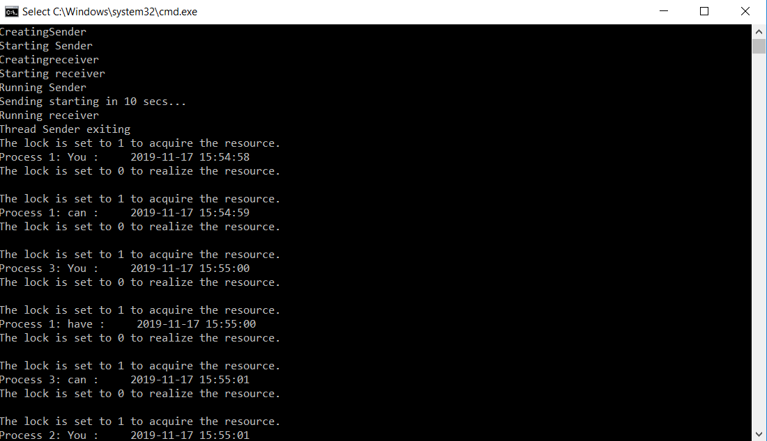

**3.**

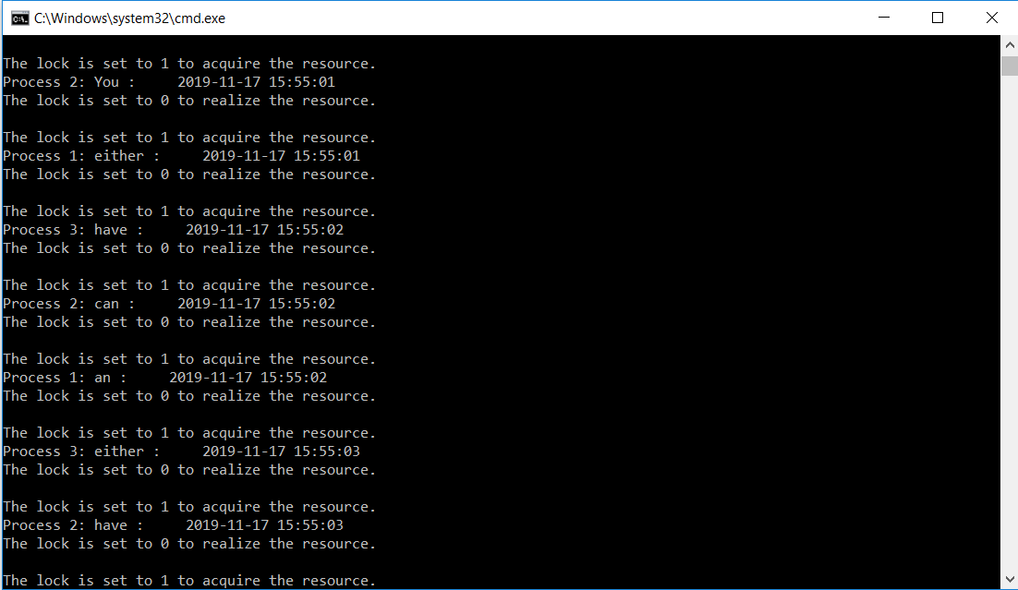

**4.**

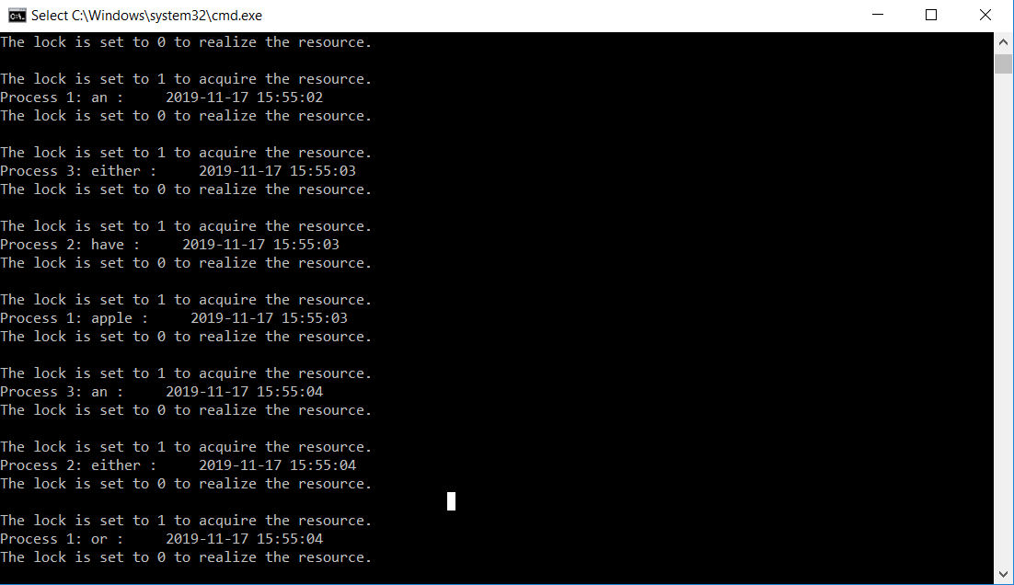

**5.**

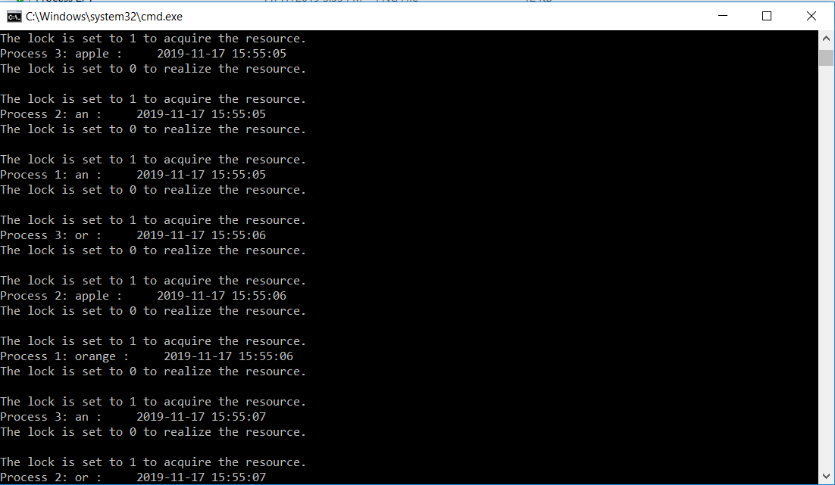

**6.**

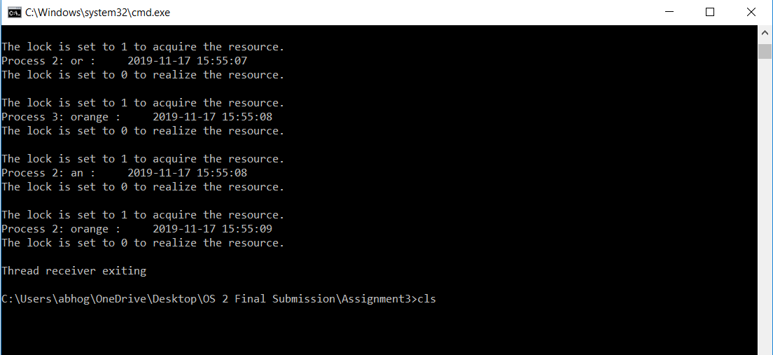

**Note: -** Output of Operation 2 & Operation 3 is like Operation 1

**Operation: 2 Output**

**1.**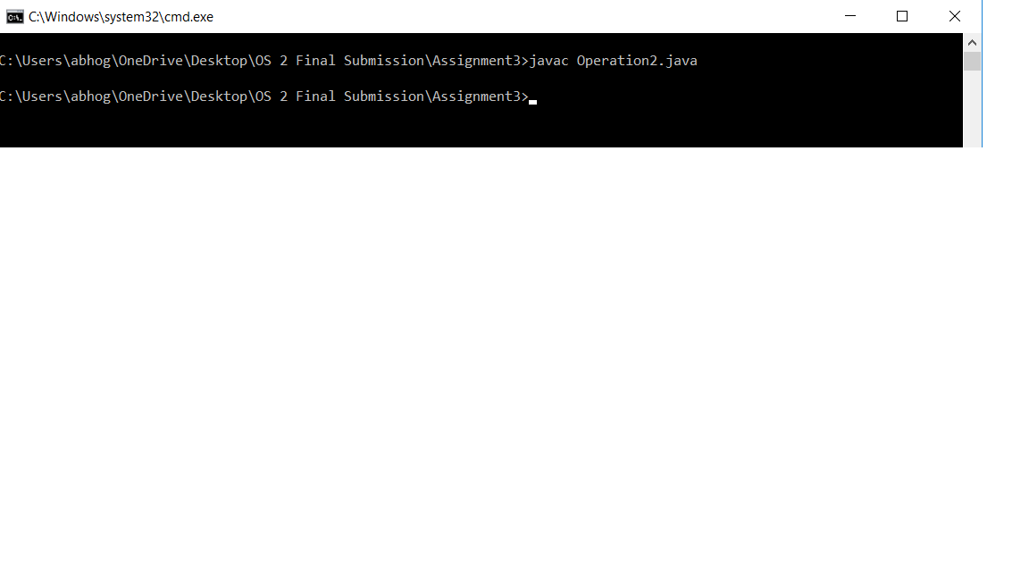

**2.**

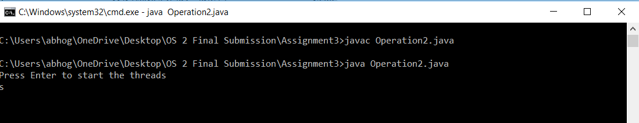

**3.**



**4.**



**5.**



**6.**



**7.**



**8.**



**Operation 3 Output: -**

**1.**

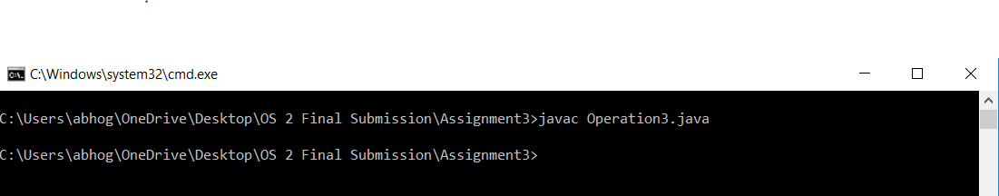

**2.**

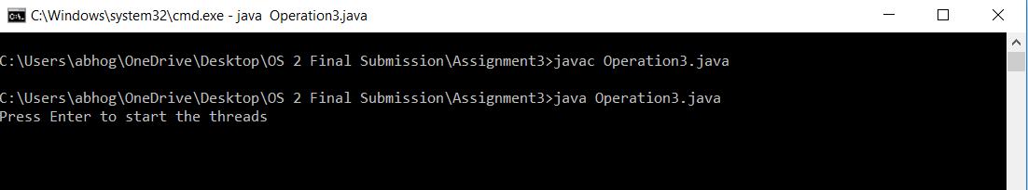

**3.**



**4.**



**5.**



**6.** 

**7.**

